Data Validation

Managing Data Checker through ICS

Revision 1, May 2016

Joseph Bon

Contents

1. Material General 4

1.1 Material Groups 5

1.1.1 Importance of Groups 5

2. Rule Configuration 5

2.1 Rule Structure 5

2.2 Obtaining Existing Rule Code 6

2.3 Updating Existing Rules (Amendments) 6

2.3.1 Requirements 6

2.3.2 Steps 7

2.4 Publishing New Rules 7

2.4.1 Requirements 7

2.4.2 Steps 7

2.5 Retiring a Rule 8

2.5.1 Steps 8

3. Diagnosing Errors 8

3.1 Reports Failing to Run 8

4. Important ICS Functions 8

4.1 Message Enquiry 8

4.2 Group Configuration 9

4.2.1 Configuring Rule Groups 9

4.3 Rule Configuration 9

4.4 Classification Configuration 10

4.4.1 Configuring Classifications 10

4.5 Email Configuration 10

4.5.1 Configuring Email Groups 10

4.5.2 Search Criteria 10

4.6 Manually Running Rule Reports 11

5. Common Fields 11

6. Translating SAP Tables to Oracle Tables 12

7. Key Sites 12

# 1. Material General

## 1.1 Material Groups

|  |  |  |  |
| --- | --- | --- | --- |
| **Group Name** | **Details** | **Schedule** | **Time (AEST)** |
| BILLOFMATERIALS | GRD Validation – Bill Of Materials | Every Monday | 02:00 AEST |
| BOM – REPORT | GRD Validation – Bill of Materials Change Report | Every Monday | 07:00 AEST |
| CONTRACT | GRD Validation – Contract | Every Monday | 08:00 AEST |
| CUSTOMER | GRD Validation – General Customers | Every Weekday | 03:00 AEST |
| **MAT RETIRED** | GRD Validation – All Materials – Retired | Every Monday | 02:00 AEST |
| **MATERIAL** | GRD Validation – Finished Goods | Every Weekday | 01:00 AEST |
| **MATERIAL – ROH** | GRD Validation – Raw Materials | Every Weekday | 04:00 AEST |
| **MATERIAL – VERP** | GRD Validation – Packing Material | Every Weekday | 02:00 AEST |
| PLANTMAINTENANCE | GRD Validation – Plant Maintenance | Every Weekday | 06:00 AEST |
| SALESORDER | GRD Validation – Sales Order | Every Weekday | 04:00 AEST |
| VENDOR | GRD Validation – Vendor | Every Weekday | 04:00 AEST |

There are several distinct material types. The Data Checker is designed to flag errors for the following material types (Referred to as “Groups” in ICS):

### 1.1.1 Importance of Groups

Every Data Checker rule must belong to one of the above groups. This is because each of these groups designed to send the appropriate reports to individuals who manage the data. These filters are followed by a second level of email groups, of which the details for can be found in Group Configuration and Email Configuration.

For Example, ANZMAT220 (A “MATERIAL” rule) may generate a report about materials from a Mars Chocolate plant. The MATERIAL group would select all of the results that are finished goods, then the second level filter would email them to the data administrators for the Mars Chocolate plant.

For example, the **MATERIAL** group selects material according to those which join to the following query:

select ltrim(sap_material_code,’0’)

from bds_material_hdr

where material_type in (‘FERT’,’ZREP’)

As the majority of the requests are in regard to material specific Data Checker rules, that will be the focus of this documentation.

# 

# 2. Rule Configuration

## 2.1 Rule Structure

There are 2 required characteristics that every Data Checker rule must have.

1. Commented Description and Changelog
2. ONLY 2 columns returned from the query
   1. VAL_KEY (The material code)
   2. VAL_MESSAGE (The error description)
      1. At the start of each VAL_MESSAGE, there must be:  
         ‘Division: ‘ || t01.material_division || ‘. Description: ‘ || t01.bds_material_desc_en

**B**

**A**

**2b**

**2a**

**1**

--##############################################################################

--# ANZMAT227

--# Check Quality Management Tab is correctly setup for TDU FERTs in Bathurst

--# (Has sister rule ANZMAT228 NAKE QM Tab)

--#

--# CHANGELOG

--# 31/08/2015 Joseph Bon: Created as per Janine Lempa @ .WOD

--##############################################################################

select t01.sap_material_code as val_key,

'Division: '

|| t01.material_division

|| '. Description: '

|| t01.bds_material_desc_en || '. '

|| t01.material_type || ' '

|| case when t01.mars_traded_unit_flag = 'X' then 'TDU' end

|| ' does not have correct quality management setup.' as val_message

from bds_material_hdr t01, /* MARA */

bds_material_plant_hdr t02 /* MARC */

where t01.sap_material_code = t02.sap_material_code

and t02.plant_code = 'AU30'

and t02.plant_specific_status in ('03','20')

and t01.material_type = 'FERT'

and t01.mars_traded_unit_flag = 'X'

and nvl(t02.documentation_reqrd_indctr,'null') != 'X'

and nvl(t02.qm_activity_authorisation_grp,'null') != 'Z00001'

and nvl(t01.qm_procurement_actv,'null') != 'X'

order by t01.sap_material_code asc

These are the additional guidelines to employ when developing Data Checker rules:

1. Changelog comments must include identification of who requested the change for accountability purposes. It is recommended that you follow the following format at the end of each changelog entry:  
   *“as per FirstName LastName @ .SITE*”
2. Alias tables sequentially: t01, t02, t03
   * Also include SAP identifier of each table (‘MARA’, ‘MARC’)

## 2.2 Obtaining Existing Rule Code

Simply run the below query as “ICS_READER” on AP0064P or AP0052T:

select *

from sap_val_rul

where var_rule = ‘ANZMAT129’

Simply substitute the identifier of the rule you want over ‘ANZMAT129’.

The “HUGEBLOB” in the “VAR_QUERY” column contains the rule code. Double click to open it in a new window, then export it as desired from there.

## 2.3 Updating Existing Rules (Amendments)

### 2.3.1 Requirements

When you receive a new rule request, ensure that it either exists on the Data Checker [SharePoint](https://team.effem.com/sites/MarsPetcareANZProcessMgmt/ANZ%20GRD%20Team/Lists/GRD%20Data%20Checker/AllItems.aspx) site, or is created after email communications begin. Due to tracking and reporting purposes, this is mandatory.

There are several pieces of information that you need before you can begin a rule amendment request:

* The name of the rule to be changed
* 3 or more examples of materials that would appear as errors (If applicable)
* An amended “VAL_MESSAGE” text template (If applicable)

Note: Make sure that all current modifications requests for each rule are combined into a single request on SharePoint (To avoid clutter).

### 2.3.2 Steps

1. Ensure:
   1. That the updated rule in its current state has been approved by the requestor to be functional.
   2. That the rule executes successfully
   3. Spelling errors and format are corrected
   4. That the rule is optimized (Google “Optimizing Oracle Queries”)
   5. That all “;” characters are removed (They act as a stop sign for SQL)
   6. That the current production version of the rule has been backed up.
2. Logon to the [ICS website](https://ap.weblogon.mars/logon/slogon.asp?platform=iis&url=http://webappdev11.ap.mars/ics_browser.asp&params=&reason=noauth) and select the “MFANZ V32 [AP0064P]” environment
3. Select “Validation Configuration” / “Rule Configuration”
4. Click on the “Update” button next to the rule to be updated
5. Paste the revised code over the existing code in the “Query” text box
6. Click “Accept” to save.
7. Also repeat the above steps in the test system (AP0052T).

Results for the revised query will be seen when the report is next executed.

## 2.4 Publishing New Rules

### 2.4.1 Requirements

Similar to updating existing rules, when you receive a request for a new rule, you must make sure that it either exists on SharePoint or is created after email communications begin. Due to tracking and reporting purposes, this is mandatory.

There are several pieces of information that you need before you can begin a new rule request:

* Rule Description (Short Summary of what the rule does)
* 3 or more examples of materials that would appear as errors (If applicable)
* Template for val_message text (See Rule Structure)
* Knowledge of what material type you are reporting on (See Material Groups)

### 2.4.2 Steps

1. Ensure:
   1. That the updated rule in its current state has been approved by the requestor to be functional.
   2. That the rule executes successfully
   3. Spelling errors and format are corrected
   4. That the rule is optimized (Google “Optimizing Oracle Queries”)
   5. That all “;” characters are removed (They act as a stop sign for SQL)

**Publishing New Rules *cont.***

1. Logon to the [ICS website](https://ap.weblogon.mars/logon/slogon.asp?platform=iis&url=http://webappdev11.ap.mars/ics_browser.asp&params=&reason=noauth) and select the “MFANZ V32 [AP0064P]” environment
2. Select “Validation Configuration” / “Rule Configuration”
3. Select the group appropriate for the rule you are publishing at the top of the screen, and click on “Insert Rule”
4. Information to populate:
   1. Name the rule according to the next sequential identifier in its group (ANZMAT221, ANZMAT222, etc.)
   2. Paste query code into “Code Query” field
   3. In the “TEST” dropdown, select “Each Row”
5. Click “Accept” to save.
6. Click “Menu” in the top right, and navigate to “Validation Configuration” / “Classification Configuration”
7. Select the group of the rule you published, and move it to the “Active” list.
8. Click “Accept” to save.
9. Also repeat the above steps in the test system (AP0052T).

Results for the new query will be seen when the report is next executed.

## 2.5 Retiring a Rule

### 2.5.1 Steps

1. Navigate to [ICS Website](https://ap.weblogon.mars/logon/slogon.asp?platform=iis&url=http://webappdev11.ap.mars/ics_browser.asp&params=&reason=noauth) and select the “MFANZ V32 [AP0064P]” environment
2. Select “Validation Configuration” / “Rule Configuration”
3. Click on the “Update” button next to the rule to be retired
4. Add “*RETIRED* ” to the start of the rule description
5. Click “Accept” to save.
6. Click “Menu” in the top right, and navigate to “Validation Configuration” / “Classification Configuration”
7. Select the group of the rule you edited, and move it from the “Active” to the “Inactive” list
8. Click “Accept” to save.
9. Also repeat the above steps in the test system (AP0052T)

# 3. Diagnosing Errors

## 3.1 Reports Failing to Run

1. Navigate to ICS
2. Select “Monitoring” then “Job Monitoring”
3. From the “Job Identifier” drop down menu, select the report that you wish to investigate
   1. EG. “(GRD_VALDTN_PACK_MATL) GRD Validation – Packing Material”
4. Click on “Search”
5. Under the “Status” menu, you may see an “Aborted” message. Click on the “Job Number” for that row to view the error message and other relevant details.

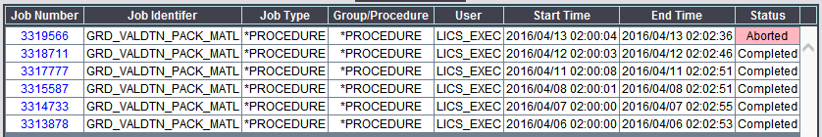

# 4. Important ICS Functions

## 4.1 Message Enquiry

Navigate to “Validation Configuration / Validation Monitoring / Message Enquiry”

This interface allows you to download the reports generated for each rule, as well as see an overview of key details for each. This is done by selecting group in the drop down menu, then clicking “enquire”.

|  |  |
| --- | --- |
| **Column** | **Function** |
| Action | Allows you to download a copy of the report. |
| Group | The group that the rule group report belongs to |
| Statistic | The type of report being generated |
| Identifier | The name of the report generated |
| Description | The description of the report |
| Valid | The amount of distinct valid materials |
| In Error | The amount of distinct materials returned as errors for a report |
| Messages | The total amount of errors (Or rows) returned when the report is generated |

## 4.2 Group Configuration

Provides a user interface for creating, updating and deleting rule Groups and their configurations.

Groups exist to filter the reports results according the type of materials that they return. This filter is the SQL query in the “Code Query” field.

For example, the “MATERIAL” group below selects all materials that have the type “FERT” or “ZREP” material types.

### 4.2.1 Configuring Rule Groups

1. Navigate to “Validation Configuration / Group Configuration”
2. Populate the fields as desired, as per Table 4.2.1 below.

|  |  |  |
| --- | --- | --- |
| ***Table 4.2.1*** | * **Group**  The rule group being configured | * **Code Length** The length of the SAP material code being used. This value should always be 18. |
| * **Description**  The description of the rule group being configured. | * **Code Query** The select query which defines which materials and selected/filtered through. |

## 4.3 Rule Configuration

Navigate to “Validation Configuration / Rule Configuration”

Provides a user interface for creating (referred to as inserting), updating and deleting rules.

|  |  |
| --- | --- |
| * **Description**  The description text for the rule | * **Test** Determines how many materials from reports are part of the appropriate rule group  (Always select “EACH_ROW”) |
| * **Query**  The SQL code that generates the report | * **Static Message** ??? |

You can filter the results by selecting a rule group from the drop down menu, then selecting “Refresh List”. To select a rule for configuration, click on “Update”.

## 4.4 Classification Configuration

Provides a user interface for creating (referred to as inserting), configuring and deleting rule classifications.

### 4.4.1 Configuring Classifications

1. Navigate to “Validation Configuration / Classification Configuration”
2. Select “Update” on the classification you wish to update.
3. Meet the requirement as per Table 4.4.1 Below

|  |  |  |
| --- | --- | --- |
| ***Table 4.4.1*** | **List Query**   * Must return ten columns   1. The SAP material code   2. Material Division   3. The rest are defined by the search criteria. See Search Criteria | **Single Query**   * Must select only the SAP Code * Must have a where clause, defined by the requirements for that classification |

## 4.5 Email Configuration

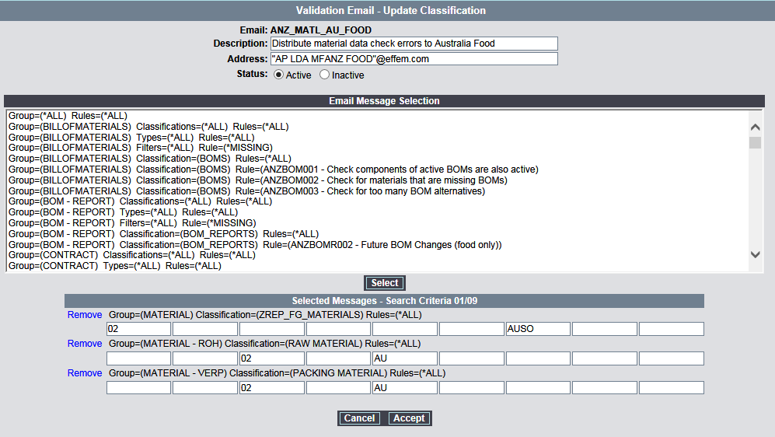Allows configuration of filtering how reports are sent to the appropriate distribution lists.

### 4.5.1 Configuring Email Groups

1. Navigate to “Validation Configuration / Email Configuration”
2. Clicking “Update” on one of the email groups.
3. Click “select” on the search criteria you wish to assign to this email group.

The “Email Message Selection” is a list of predefined search criteria. You can read about search criteria here.

### 4.5.2 Search Criteria

“Selected Messages” contains all of the search criteria chosen for that email. The 9 fields of search criteria follow these headings:

|  |  |  |  |  |  |  |  |  |
| --- | --- | --- | --- | --- | --- | --- | --- | --- |
| *Division* | *Snack* | *Food* | *Pet* | *AU Plant* | *NZ Plant* | *AU sales org* | *NZ Sales org* | *NULL* |
|  |  |  |  |  |  |  |  |  |

The nature of the search criteria can’t necessarily be understand at first glance, below is what each field means.

|  |  |
| --- | --- |
| **Field** | **Details** |
| Division | Obtained from bds_material_hdr, the materials division |
| Snack | Raw and Pack materials don’t have a division on bds_material_hdr. Therefore, this field is populated when the material exists in a MOE from any of these divisions. *(Table: bds_material_moe)* |
| Food |
| Pet |
| AU Plant | If a material exists in an AU plant, this field is populated. |
| NZ Plant | If a material exists in an NZ plant, this field is populated. |
| AU Sales Org | If a material has an Australian Sales Organisation, this field is populated. |
| NZ Sales Org | If a material has a New Zealand Sales Organisation, this field is populated. |
| NULL | ??? |

## 4.6 Manually Running Rule Reports

This interface allows a manual execution of any of the groups of rule validation.

1. Navigate to the [ICS Website](http://webappdev11.ap.mars/ics_browser.asp?iAUTH=4W6iyZxjHLc058+Km5MxjOhjC/0w2PLlmdI9XqENIixZTF5dyjlrwvTSqUwbUgYZC7vounXqY4iEN1UCjhhzOQ==)
2. Select the “AP0064P” Environment
3. Navigate to “Validation Configuration / Batch Execution”
4. Select a group from the drop down menu, then click “Submit” to have it run.

# 5. Common Fields

|  |  |  |
| --- | --- | --- |
| **Table** | **Field** | **Description** |
| bds_material_hdr | mars_traded_unit_flag | Trading Unit Flag |
| mars_retail_sales_unit_flag | Retail Sales Unit Flag |
| mars_merchandising_unit_flag | Merchandising Unit Flag |
| material_division | Material Division |
| bds_material_desc_en | Material Description |
| material_type | Material Type |
| xplant_status | GRD Status |
| bds_material_plant_hdr | plant_specific_status | Plant Status |
| bds_material_dstrbtn_chain | dstrbtn_chain_status | Sales Status |
| bds_material_uom | uom_code | Unit of Measure |
| bds_material_moe | usage_code | Material Function |

# 6. Translating SAP Tables to Oracle Tables

|  |  |  |  |
| --- | --- | --- | --- |
| **SAP Table** | **Oracle Table** | **Schema** | **Description** |
| ADRC | bds_addr_customer | BDS | Customer Address List |
| KNB1 | bds_cust_comp | BDS | Customer Company |
| KNA1 | bds_cust_header | BDS | Customer Header |
| KNVV | bds_cust_sales_area | BDS | Customer Sales Area |
| CLFMAS01 | bds_customer_classfctn | BDS | Customer Classification |
| BOMMAT | bds_material_bom_hdr | BDS | Bill of Material Header |
| CLFMAS01/BMCL | bds_material_classfctn | BDS | Material Classification |
| CLF | bds_material_classfctn_en | BDS | Material Classification (English) |
| MVKE | bds_material_dstrbtn_chain | BDS | Material Distribution Chain |
| MARA | bds_material_hdr | BDS | Material Header |
| MOE | bds_material_moe | BDS | Material Mars Organisational Entity |
| PIKP | bds_material_pkg_instr_hdr | BDS | Material Packing Instruction Header |
| MARC | bds_material_plant_hdr | BDS | Material Plant Data |
| MARM | bds_material_uom | BDS | Material Unit Of Measure |
| MBEW | bds_material_vltn | BDS | Material Valuation |
| LFA1 | bds_vend_header | BDS | Vendor Header |
| PDET | lads_prc_lst_det | LADS | LADS Price List Detail |
| PHDR | lads_prc_lst_hdr | LADS | LADS Price List Header |
| PQUA | lads_prc_lst_qua | LADS | LADS Price List Quantity |
| PLVA | lads_prc_lst_val | LADS | LADS Price List Value |
| T001W | temp_bom_hdr | LADS | Temporary Bill of Material Header |

# 7. References

|  |  |
| --- | --- |
| SharePoint | <https://team.effem.com/sites/MarsPetcareANZProcessMgmt/ANZ%20GRD%20Team/Lists/GRD%20Data%20Checker/AllItems.aspx> |
| ICS Website (Interface Control System) | <http://webappdev11.ap.mars/ics_browser.asp?iAUTH=4W6iyZxjHLc058+Km5MxjOhjC/0w2PLlmdI9XqENIixZTF5dyjlrwvTSqUwbUgYZC7vounXqY4iEN1UCjhhzOQ>== |